Scholar Tracking System
Project report submitted in partial in fulfillment of the requirement of SkillEcted Educations by JSSAV Educations Pvt. Ltd.

Submitted by
Name: Kajal Kumari
Course: Data Science

Under the supervision of
Mr. Akash Upadhyay

Skillected Educations by JSSAV Educations
Pvt. Ltd Pune

DECLARATION

Thesis Title: “Scholar Tracking System”.

I hereby declare that the project entitled “Scholar Tracking System” submitted by me is a bonafide record of work carried out under the guidance of my teacher. This project is submitted in partial fulfillment of the requirements for the completion of my course.
I also declare that this work has not been submitted previously to any other institution for the award of any degree. All the sources used in this project have been duly acknowledged.

Name:
Roll Number:
Course:
Date:
Signature: _____________

CERTIFICATE

This is to certify that the project titled “Scholar Tracking System” is a bonafide work carried out by [Your Name], bearing Roll Number [Your Roll No.], under my guidance and supervision.
This project report is submitted in partial fulfillment of the requirements for the completion of the course [Your Course Name]. The work presented in this project is original and has not been submitted elsewhere for any degree.
I wish the student success in all future endeavors.

Guide/Instructor Name:____________________
Signature: ____________________
Head of Department:____________________
Signature: ____________________
Date:____________________
Place: ____________________

ABSTRACT
The Scholar Tracking System is a database-based application designed to efficiently manage and monitor student scholarship information. The main objective of this system is to store, track, and analyze the details of scholars, including their academic performance, eligibility, and scholarship status.
In traditional methods, maintaining scholarship records manually is time-consuming and prone to errors. This system overcomes such challenges by providing a structured and automated way to handle large amounts of student data. It uses SQL for data storage, retrieval, and management, ensuring accuracy and quick access to information.
The system allows administrators to add, update, and delete student records, check eligibility criteria, and generate reports. It also helps in tracking the progress of students and ensures transparency in scholarship distribution.
Overall, the Scholar Tracking System improves efficiency, reduces manual work, and provides a reliable platform for managing scholarship-related data.

ACKNOWLEDGEMENT

I would like to express my sincere thanks to my respected guide [Guide Name] for their continuous guidance, support, and valuable suggestions throughout the development of my project titled “Scholar Tracking System.” Their encouragement played an important role in the successful completion of this work.
I am also thankful to [College/Institute Name] for providing the necessary facilities and environment to complete this project.
I would like to thank my friends and classmates for their cooperation and helpful ideas during the project work.
Finally, I express my heartfelt gratitude to my parents and family members for their constant support, motivation, and encouragement.

Table of Contant
S.NO. | TITLE | PAGE NO.
1. | Declaration
2. | Certificate
3. | Abstract
4. | Acknowledgement
5. | Literature Survey
 | Introduction
 | Existing System
Disadvantage of
Existing System
6. | Analysis
 | Introduction
 | Software Requirement Specification
 | User Requirement
 | Software Requirement
 | Content Diagram or Architecture of Project
7. | System Design
 | Introduction
 | Use Case Diagram
 | Data Flow Diagram
 | Activity Diagrams
 | DFD/ER/UML Diagram
8. | Database Design
9. | Coding
10. | Conclusion

Literature Survey
Introduction:
A Scholar Tracking System is a digital platform designed to manage and monitor the academic progress and records of students (scholars) efficiently. It helps educational institutions store, organize, and track important student information such as personal details, academic performance, attendance, and achievements in a centralized database.

In traditional systems, maintaining student records manually can be time-consuming, error-prone, and difficult to update. The Scholar Tracking System overcomes these challenges by providing an automated and user-friendly solution. It ensures accuracy, quick access to data, and better management of scholar-related information.

This system is especially useful for administrators, teachers, and institutions to analyze student progress, generate reports, and make informed decisions. By using technologies like databases (SQL), web interfaces, and secure login systems, the Scholar Tracking System improves efficiency, transparency, and overall academic management.

Security:
The Scholar Tracking System ensures the protection of sensitive student data through various security measures. It uses user authentication to allow access only to authorized users such as administrators and staff. Role-based access control restricts users from performing unauthorized actions.

To prevent data misuse, the system applies input validation and secure database operations. Passwords are stored securely, and regular data backups are maintained to avoid data loss. These measures help maintain confidentiality, integrity, and availability of information.

Services:
The Scholar Tracking System provides multiple services to simplify student data management:

- Student Information Management: Add, update, and delete student records.
- Performance Tracking: Monitor marks, grades, and academic progress.
- Attendance Management: Maintain attendance records.
- Report Generation: Generate academic and administrative reports.
- Search Functionality: Easily retrieve student data.
- User Management: Control access and manage system users
These services improve efficiency and reduce manual workload.

Results:
The implementation of the Scholar Tracking System delivers several positive outcomes:
- Increased accuracy in data management
- Reduced manual effort and paperwork
- Quick and easy access to information
- Improved tracking of student performance
- Efficient report generation for decision-making
Overall, the system enhances productivity and ensures better management of scholar records.

Existing System

The existing system for managing scholar information is mostly manual or partially computerized. Data is stored in paper records or basic tools like spreadsheets.
- Scholar details are recorded manually
- Data is maintained in files or registers
- No centralized database system
- Tracking student performance is difficult
- Report generation is done manually

Disadvantages of Existing System:
The current system has several drawbacks:
- Time-consuming process for searching and updating records.

- High chances of errors due to manual handling.
- Data redundancy (duplicate data entries)

- Poor data security (risk of data loss or unauthorized access)

- No real-time updates

- Difficult to generate reports quickly

- Lack of proper data management system

Proposed System:
The proposed system is a Scholar Tracking System using a database (SQL) to automate and manage all scholar-related activities efficiently.
- Centralized database to store all scholar information
- Easy data entry, update, and deletion
- Quick search and retrieval of records
- Real-time tracking of scholar progress
- Secure login system for authorized users
- Automatic report generation
- User-friendly interface

Advantages of Proposed System:
- Saves time and reduces manual work
- Improves accuracy and reduces errors
- Ensures better data security
- Provides quick access to information
- Generates reports instantly
- Efficient and reliable system
Analysis
Introduction:
The analysis phase of the Scholar Tracking System focuses on understanding current issues in managing scholarships. Existing systems are often manual and inefficient, causing errors and delays. This analysis identifies user requirements and system needs to develop a centralized, accurate, and user-friendly solution for tracking scholarship information effectively.

Software Requirement Specification:
The Scholar Tracking System is designed to manage and track scholarship details of students efficiently. It helps institutions store, update, and monitor scholarship data in a centralized system.

User Requirement
- Users should be able to register and login securely
- Students can apply for scholarships
- Users can view and track scholarship status
- Admin can add, update, and manage student records
- System should allow searching student details easily
Software Requirement:
Database: MySql / DBMS
Tools: MySql Workbench

Architecture Project:
The Architecture of a Scholar Tracking System refers to the overall structure and organization of components that work together to manage scholarship data, process applications, and provide results to user.

It defines how different parts of the system-such as the user interface, processing logic, and SQL database-inteact with each other to ensure smooth data flow, security, and efficient performance.

In this system, architecture ensures that student information, scholarship details, and application status are properly handled, stored, and retrieved using SQL, while maintaining accuracy and reliability.

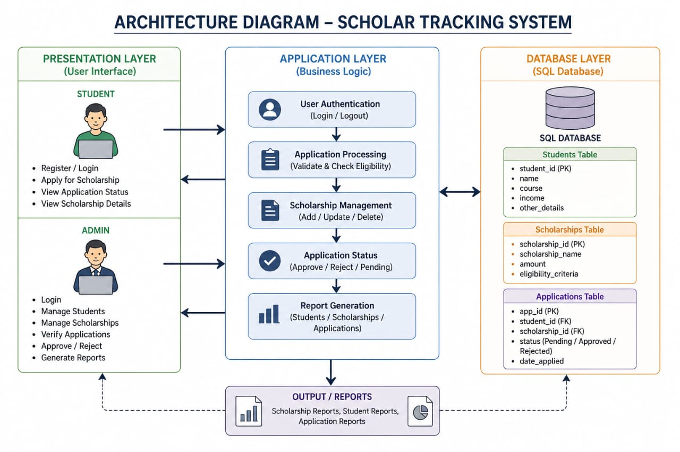

System Design
Introduction:
System design is the process of defining the architecture, components, modules, interfaces, and data flow of a system to meet user requirements. In a Scholar Tracking System, system design plays an important role in organizing how scholarship data is stored, processed, and managed efficiently.
The Scholar Tracking System is designed to automate the process of tracking student scholarships, reducing manual work and errors. It provides a structured platform where administrators and users can manage student details, scholarship records, application status, and fund distribution.
The system is divided into different modules such as:
- Student Management Module
- Scholarship Management Module
- Application Tracking Module
- Report Generation Module

UML Diagrams
Use Case Diagram
A Use Case Diagram is a type of UML diagram that represents the interaction between users (actors) and the system. It shows what the system does from the user’s perspective and helps in understanding system functionality.
In the Scholar Tracking System, the Use Case Diagram identifies how students and administrators interact with the system to manage scholarship processes.

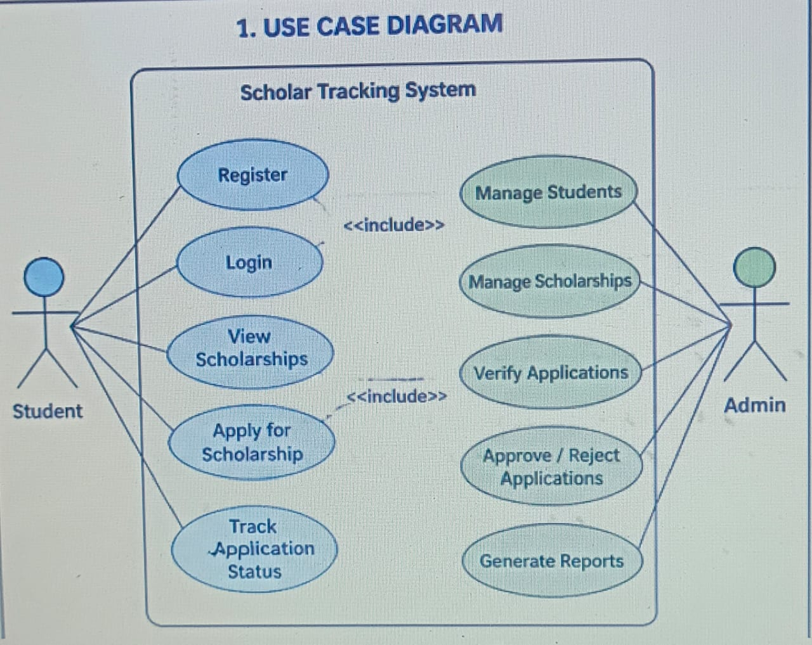
DATA FLOW DIAGRAMS:
DATA FLOW DIAGRAMS:

- 0Level DFD For Scholar Tracking System

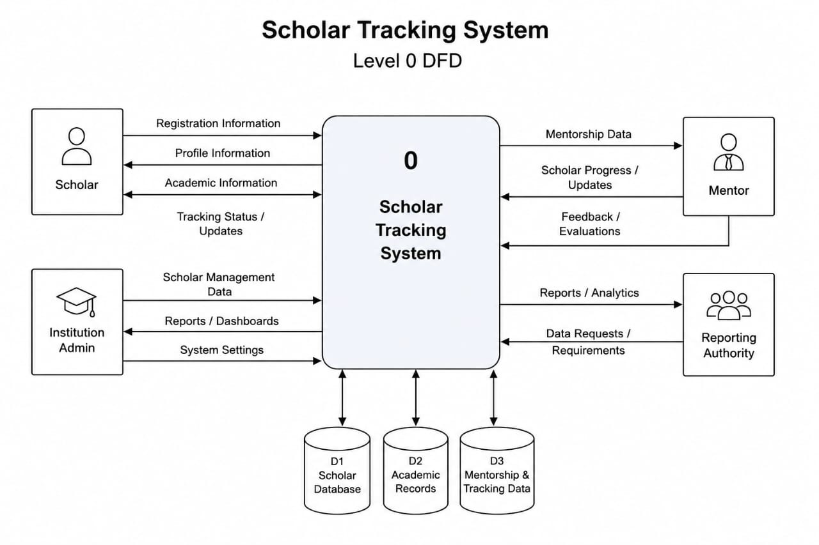
- Level 1 DFD For Scholar Tracking System

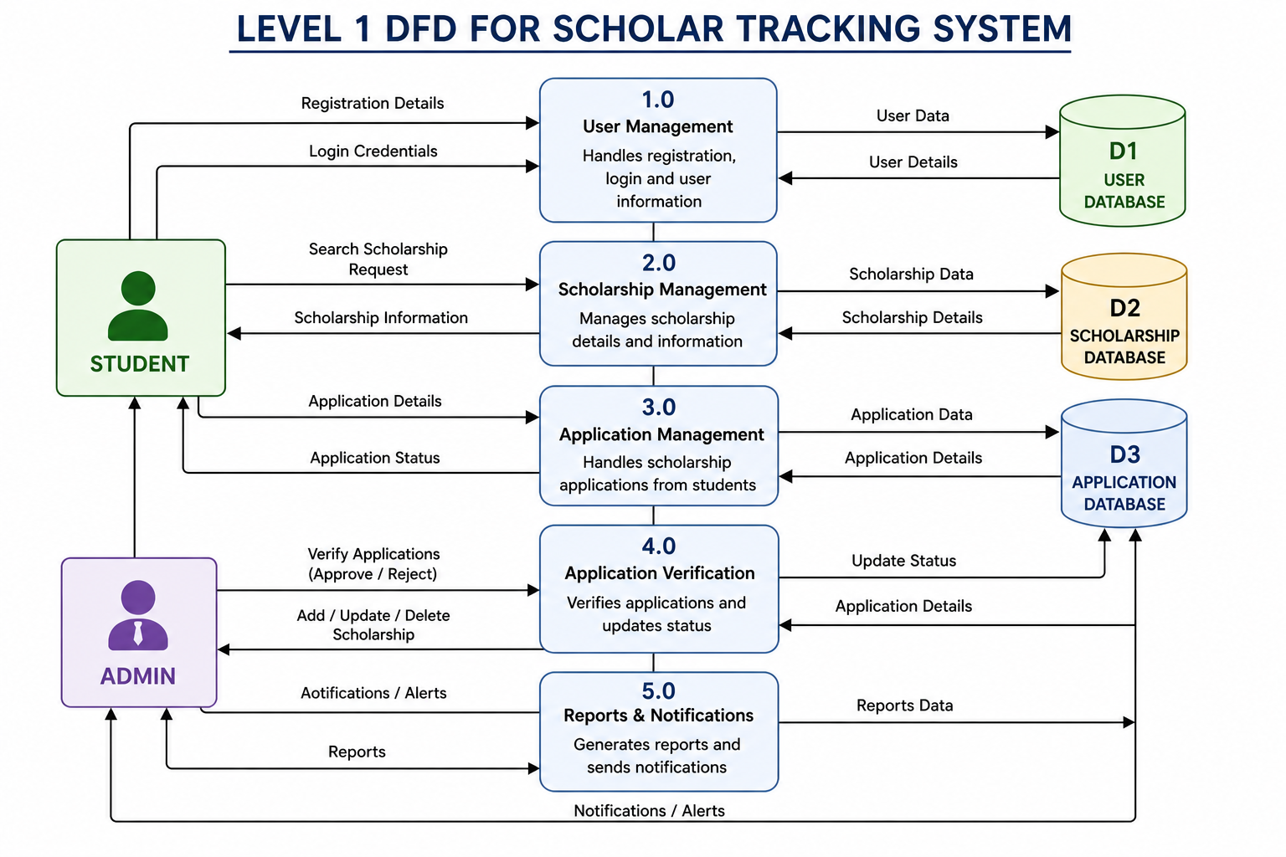

ACTIVITY DIAGRAM

Login Activity Diagram Of Scholar Tracking System:

The login activity diagram of the Scholar Tracking System represents the complete flow of the login process, where the user (student or admin) enters their username and password, the system first checks whether the input fields are filled correctly, then validates the credentials against the database, and based on the result, either grants access by redirecting the user to their respective dashboard or displays an appropriate error message in case of invalid or missing details, ensuring secure and efficient access to the system.

Activity Diagram For Admin Login

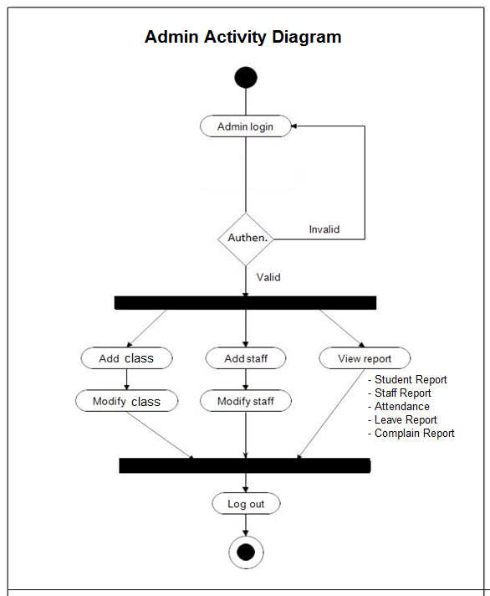

Class Diagram
A class diagram is a type of UML (Unified Modeling Language) diagram that represents the structure of a system by showing its classes, attributes, methods, and the relationships between them.
In a Scholar Tracking System, a class diagram visually describes how different components like Student, Scholarship, Admin, Application, and Report are organized and how they interact with each other. It helps in designing the system by clearly defining data and functionality before implementation.

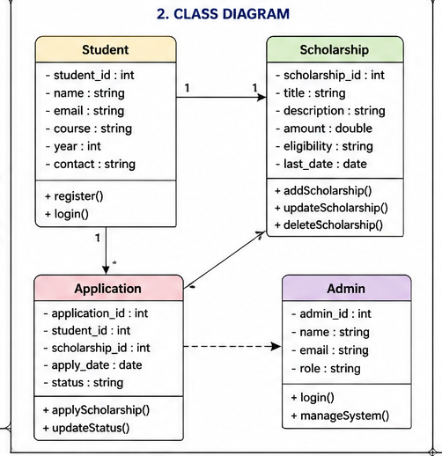
SEQUENCE DIAGRAM:

A sequence diagram is a graphical representation that focuses on the step-by-step interaction between system components, arranged in a time sequence from top to bottom. It shows how objects communicate by sending messages to each other to complete a specific task or process.

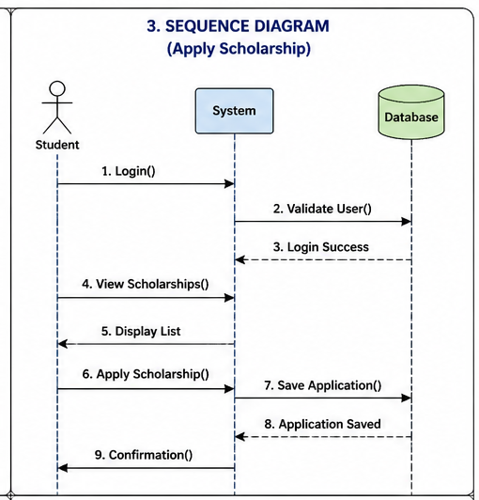
ENTITY RELATIONSHIP DIAGRAM

Entity Relationship Diagram:
An Entity Relationship Diagram (ERD) is a type of data modeling diagram used to represent the structure of a database. It shows the entities (objects), their attributes (properties), and the relationships between them.
In a Scholar Tracking System, an ER diagram helps to organize data such as Student, Scholarship, Application, and Admin, and shows how these entities are connected (for example, a student applies for a scholarship).

Database Design:
Database design is the structured process of defining and organizing data within a database by identifying entities, attributes, relationships, and constraints, in order to ensure efficient data storage, retrieval, integrity, and security in a database system.

Database Design

Database design is a systematic and organized process of creating the structure of a database by identifying data requirements, entities, attributes, relationships, and constraints, so that data can be stored, managed, and retrieved efficiently. It ensures that the database is accurate, consistent, secure, and optimized for performance.

This process involves analyzing user needs and translating them into a logical structure using models like ER diagrams, followed by converting them into tables with proper primary keys, foreign keys, and normalization rules. Database design also includes planning how data will be physically stored, indexed, and accessed in a database management system.

A well-designed database minimizes data redundancy, avoids data anomalies, and supports scalability and future growth. It plays a crucial role in ensuring that applications run smoothly and data operations are performed quickly and reliably.

Code
Create database
Create database ScholarshipTrackingSystem
Use ScholarshipTrackingSystem

Create Table
Student Table:
create table students (Student_id int primary key auto_increment, Name varchar(70),Email varchar(100),
Phone varchar(20), Course varchar(50),Year int);
insert into students (name, email, phone, course, year) values
('Rahul Kumar','rahul@gmail.com','9876543210','BCA',2),
('Anjli Singh','anjli@gmail.com','9123456780','BSc',1),
('Rani Sharma','rani@gmail.com','9345678104','BAC',1),
('Ravi Kumar','ravi@gmail.com','8123498760','B.Tech',3),
('Sanvi Varma','sanvi@gmail.com','9876123450','MAC',2);
select * from students;

Scholarship Table:
create table scholarships (Scholarship_id int primary key auto_increment, Scholarship_name varchar(100),
Provider varchar(100), Amount decimal(10,2),Eligibility text);

insert into scholarships (Scholarship_name, Provider, Amount, Eligibility) values
('Matric Scholarship', 'Government', 15000, 'Above 75% marks'),
('Need-Base Scholarship', 'NGO', 30000,'Low income family'),
('Intermediate Scholarship,' 'Government', 20000,'Above 80% marks'),
('Unvesity Scholarship', 'Center Government', 650000, 'All Unvesity Students'),
('Metric Scholarship' ,'Government', 30000,'Above 85% marks');
select * from Scholarships;

Application Table:
create table Applications(application_id int primary key auto_increment, student_id int, scholarship_id int, apply_date date,status varchar(50), foreign key (student_id)
references students (student_id), foreign key (scholarship_id) references scholarships (scholarship_id));
insert into Applications (student_id, scholarship_id, apply_date, status) values
(1,1, '2026-05-01','Pending'),
(2,2, '2026-04-28','Pending'),
(3,3, '2026-04-15','Approved'),
(4,4, '2026-04-03','Approved'),
(5,5, '2026-03-25','Approved');
select * from Applications;

View All Application:
Select student_name,scholarship_name,apply_date,application_status from applications inner join
students on applications.student_id=students.student_id inner join scholarships on applications.scholarship_id=
scholarships.scholarship_id;

Check Approved Scholarship:
select student_name,scholarship_name from applications inner join students on applications.student_id=
students.student_id inner join scholarships on applications.scholarship_id=scholarships.scholarship_id
where application_status='Approved';

Count Applications Per Scholarship:
Select scholarships.scholarship_name, count(*) as total_applications from applications inner join scholarships
on applications.scholarship_id= scholarships.scholarship_id group by scholarships.scholarship_name;

